**Demonstrate how elements are located using Selenium WebDriver.**

**package** demo;

**import** org.openqa.selenium.By;

**import** org.openqa.selenium.edge.EdgeDriver;

**public** **class** AlertMessage {

**public** **static** **void** main(String[] args) **throws** InterruptedException {

// 1)open the browser

EdgeDriver driver = **new** EdgeDriver();

// 2) maximize it

driver.manage().window().maximize();

// 3)navigate to application

driver.get("https://retail.onlinesbi.sbi/retail/login.htm");

// 4) click on continue to login button

driver.findElement(By.*linkText*("CONTINUE TO LOGIN")).click();

// 5) click on login button

driver.findElement(By.*id*("Button2")).click();

Thread.*sleep*(3000);

// 6) close the alert box

driver.switchTo().alert().accept();

}

}

**OUTPUT:**

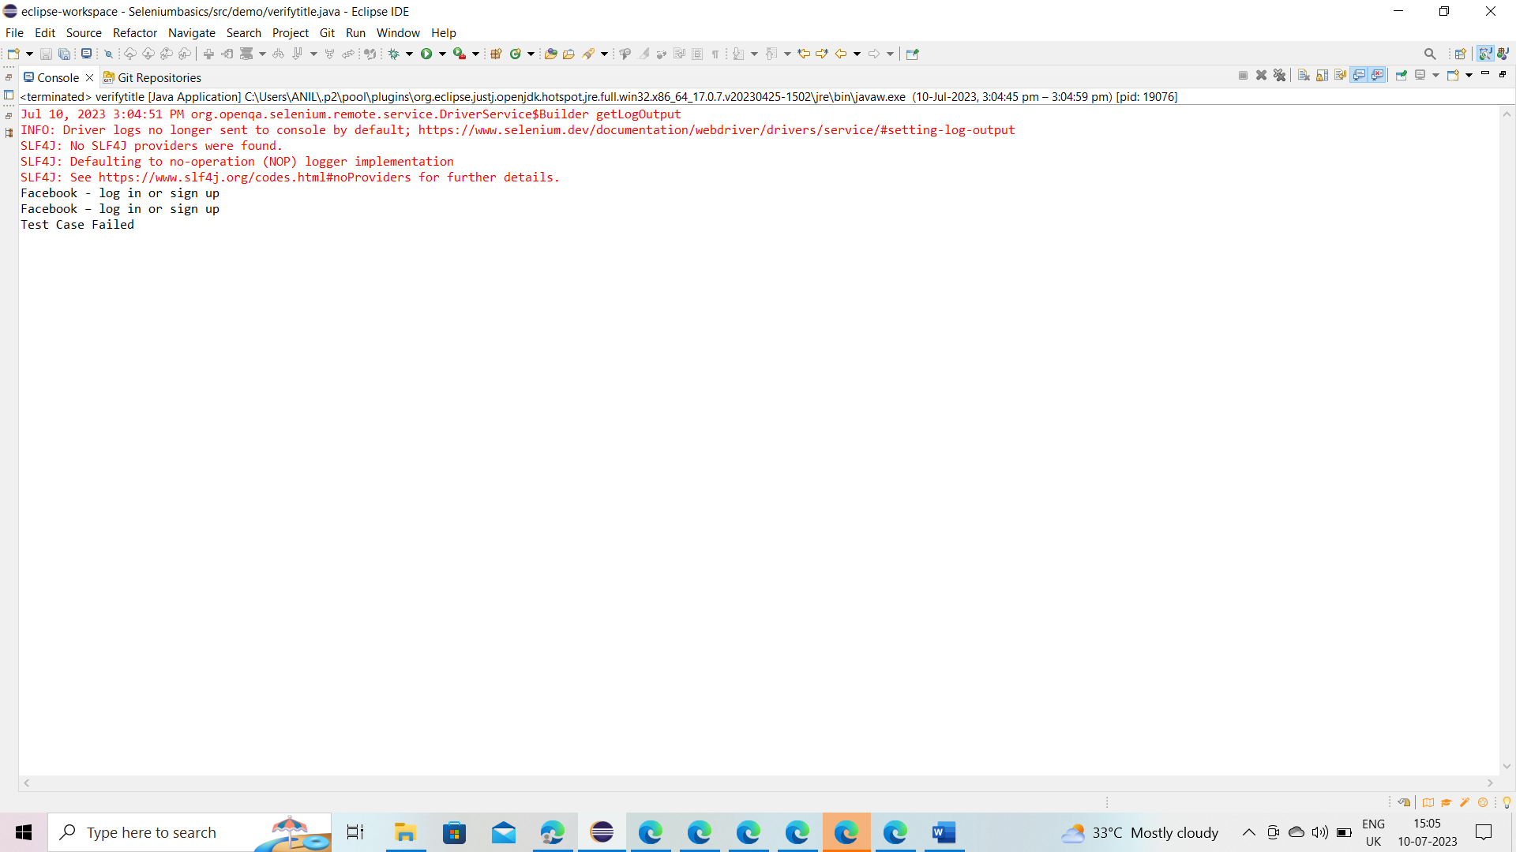

**Demonstrate how elements are located through CSS and XPath**

package demo;

import org.openqa.selenium.By;

import org.openqa.selenium.edge.EdgeDriver;

public class verifyErrorMessage {

public static void main(String[] args) {

// 1) Open the browser

EdgeDriver driver = new EdgeDriver();

// 2) Navigate to application

driver.get("https://facebook.com");

// 3) Enter invalid username 'batman423@gmail.com' in the Email address or phone number textbox

driver.findElement(By.id("email")). sendKeys("batman423@gmail.com");

// 4) Enter invalid Password 'Pass@123' in the Password textbox

driver.findElement(By.id("pass")). sendKeys("Pass@123");

// 5) Click Login

driver.findElement(By.name("login")). click();

// 6) Verify user sees the error message - "The email address you entered isn't connected to an account. Find your account and log in."

String excpectedTitle = "The email address you entered isn't connected to an account. Find your account and log in.";

String actualTitle = driver.findElement(By.xpath("(//div[contains(@class, 'ay')])[3]")).getText();

if(excpectedTitle.equals(actualTitle)) {

System.out.println("Test Case Passed");

}

else {

System.out.println("Test Case Failed");

}

// 7) Close the browser

driver.quit();

}

}

OUTPUT:

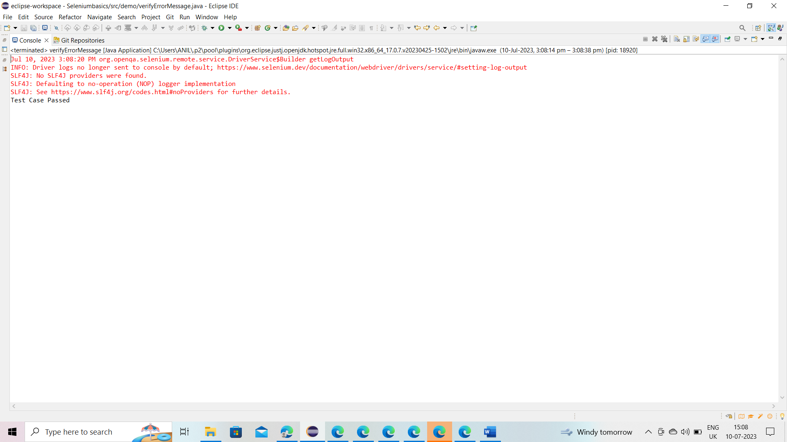

**package** demo;

**import** java.time.Duration;

**import** org.openqa.selenium.By;

**import** org.openqa.selenium.edge.EdgeDriver;

**import** org.openqa.selenium.support.ui.ExpectedConditions;

**import** org.openqa.selenium.support.ui.WebDriverWait;

**public** **class** explicitwaitdemo {

**public** **static** **void** main(String[] args) {

// 1) Open the browser

EdgeDriver driver = **new** EdgeDriver();

// 2) Maximize it

driver.manage().window().maximize();

// 3) Navigate to application

driver.get("https://whitecircleschool.com/explicit-wait-demo1/");

// 4) Click 'Start' button

driver.findElement(By.*id*("start")).click();

// 5) Verify the text "Hello World!" appears on the web-page

String expectedText = "Hello World!";

//Explicit wait

WebDriverWait wait = **new** WebDriverWait(driver, Duration.*ofSeconds*(60)); //wait for a max time of 60sec

wait.until(ExpectedConditions.*visibilityOfElementLocated*(By.*cssSelector*("#finish > h4")));

String actualText = driver.findElement(By.*cssSelector*("div[id='finish'] h4")).getText();

**if**(actualText.equals(expectedText)) {

System.***out***.println("Test case passed");

}

**else** {

System.***out***.println("Test case failed");

}

// 6) Close the browser

driver.quit();

}

}

Output:

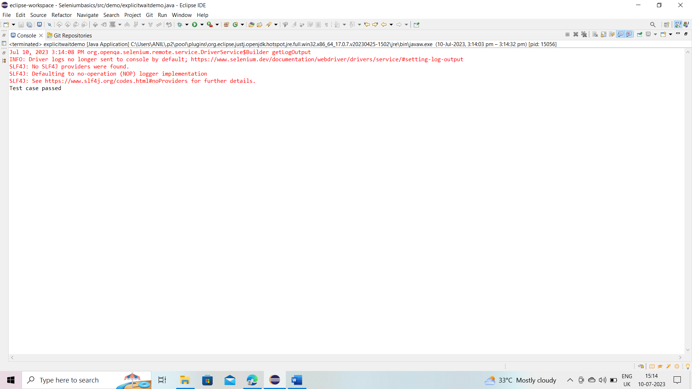

**package** demo;

**import** org.openqa.selenium.By;

**import** org.openqa.selenium.WebElement;

**import** org.openqa.selenium.edge.EdgeDriver;

**import** org.openqa.selenium.support.ui.Select;

**public** **class** dropdown{

**public** **static** **void** main(String[] args) {

EdgeDriver driver = **new** EdgeDriver();

driver.manage().window().maximize();

driver.get("https://letcode.in/dropdowns");

WebElement languages = driver.findElement(By.*id*("lang"));

Select select = **new** Select(languages);

select.selectByVisibleText("Java");

}

}

Output:

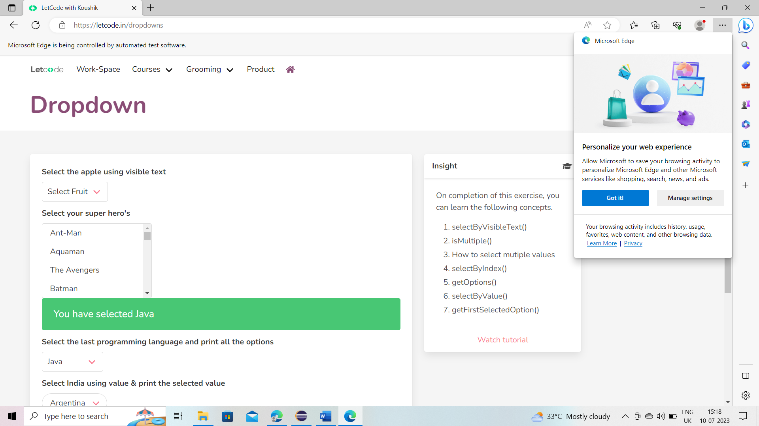

**package** demo;

**import** java.util.List;

**import** org.openqa.selenium.By;

**import** org.openqa.selenium.WebElement;

**import** org.openqa.selenium.edge.EdgeDriver;

**public** **class** tabledemo {

**public** **static** **void** main(String[] args) {

EdgeDriver driver = **new** EdgeDriver();

driver.manage().window().maximize();

driver.get("https://letcode.in/table");

WebElement firstTable = driver.findElement(By.*id*("shopping"));

List<WebElement> rows = firstTable.findElements(By.*tagName*("tr"));

**int** sum = 0;

**for** (**int** i = 1; i < rows.size(); i++) {

WebElement row = rows.get(i);

List<WebElement> columns = row.findElements(By.*tagName*("td"));

**int** price = Integer.*parseInt*(columns.get(1).getText());

sum = sum + price;

}

**int** expectedSum = 858;

**if** (expectedSum == sum) {

System.***out***.println("Test Case Passed");

} **else** {

System.***out***.println("Test Case Failed");

}

driver.quit();

}

}

Output:

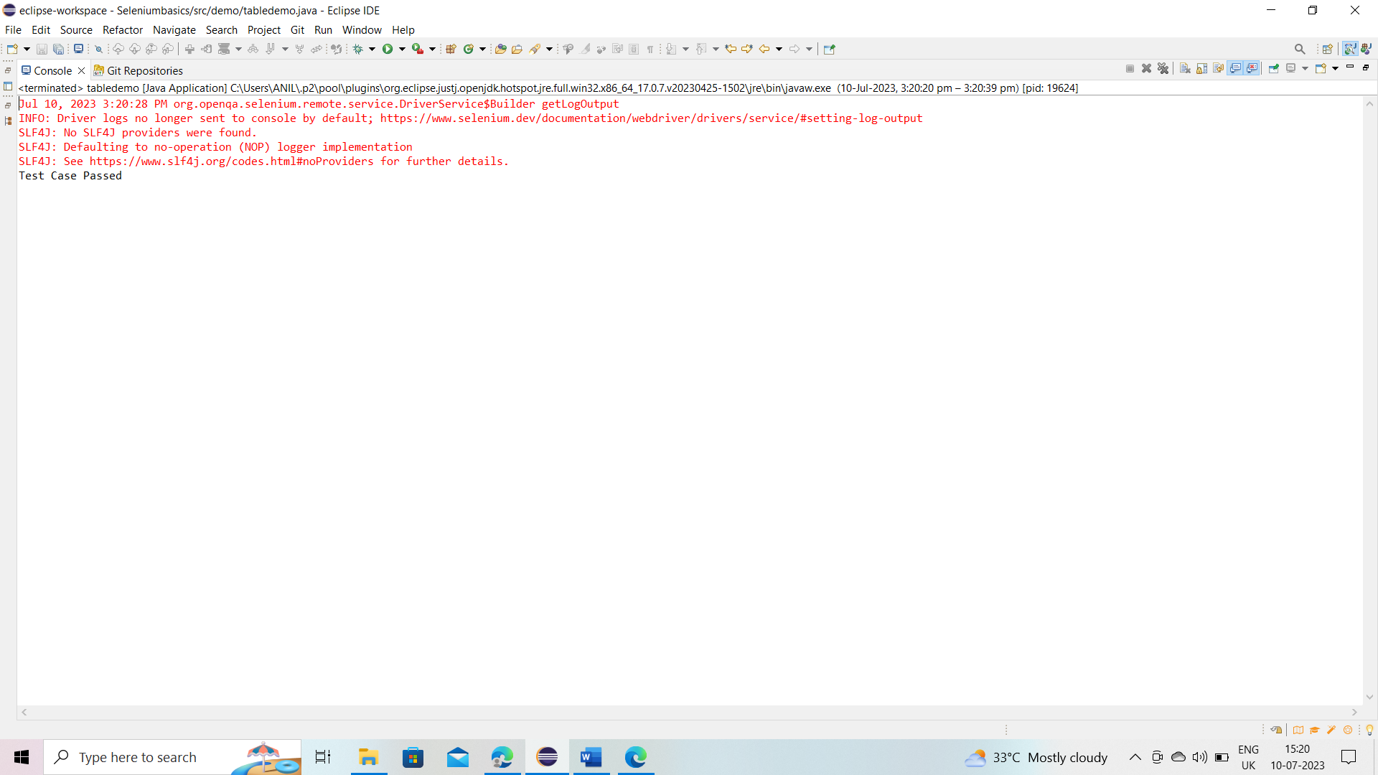

**package** demo;

**import** org.openqa.selenium.By;

**import** org.openqa.selenium.edge.EdgeDriver;

**public** **class** radiobtncheckbox {

**public** **static** **void** main(String[] args) {

// 1) Open the browser

EdgeDriver driver = **new** EdgeDriver();

// 2) Maximize it

driver.manage().window().maximize();

// 3) Navigate to application

driver.get("https://letcode.in/radio");

// 4) Select 'Yes' radio button from 'Select any one' option

driver.findElement(By.*id*("yes")).click();

// 5) Check last check box

driver.findElement(By.*xpath*("//body[1]/app-root[1]/app-radio-check[1]/section[1]/div[1]/div[1]/div[1]/div[1]/div[1]/div[7]/label[2]/input[1]")).click();

// 6) Close the browser

driver.quit();

}

}

Output:

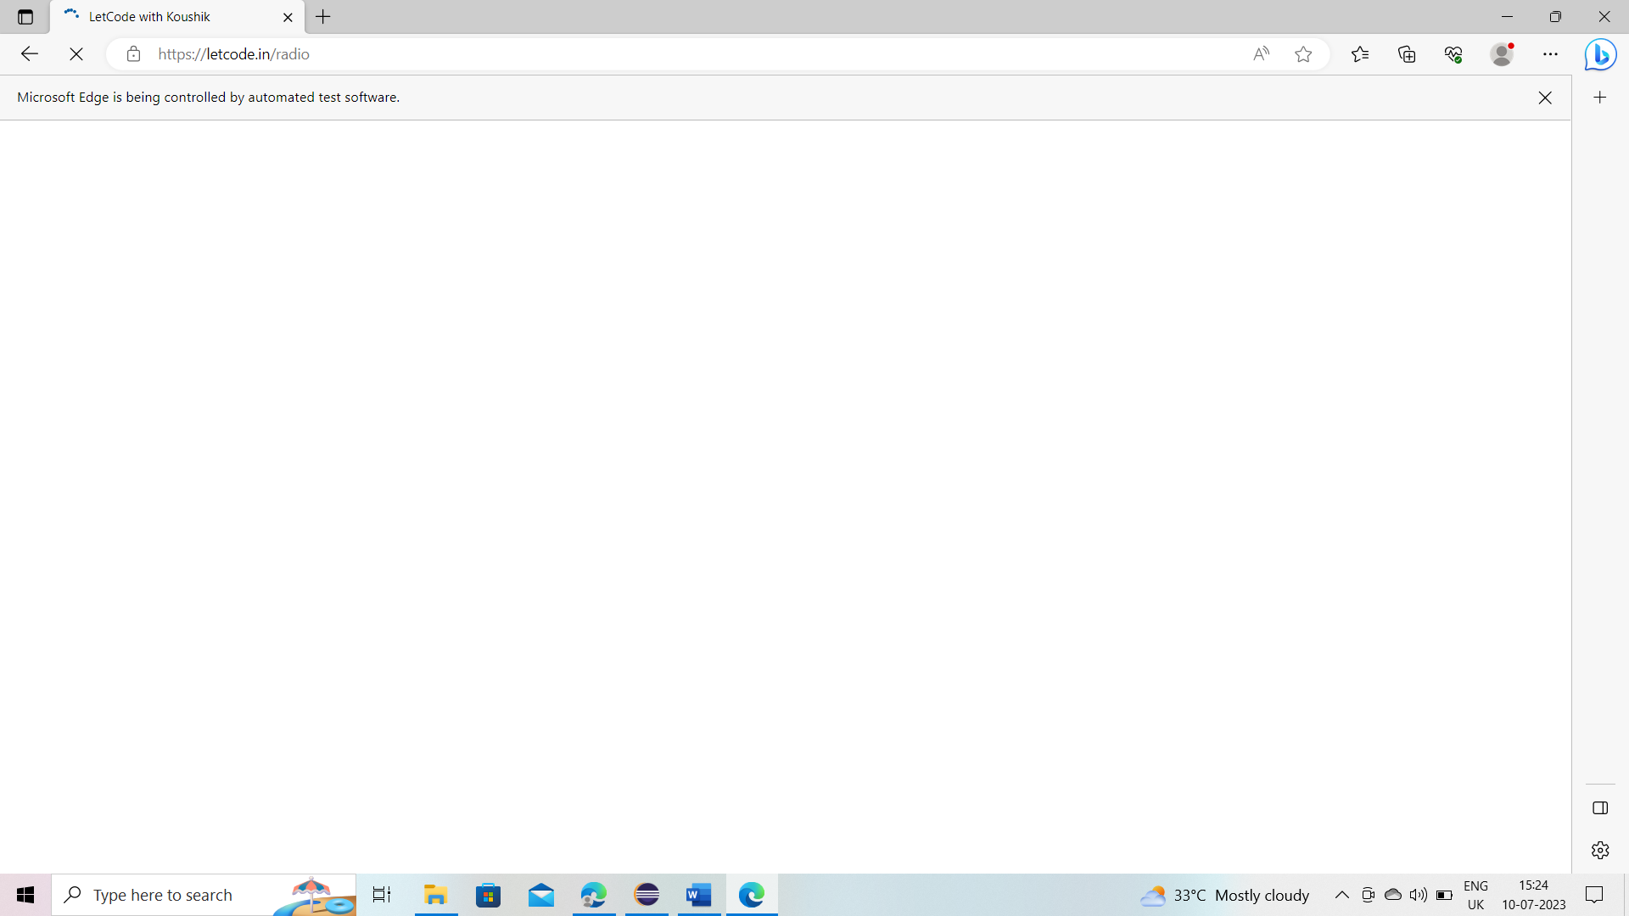

**Demonstrate how to automate calendars on the web page**

**package** demo;

**import** java.util.List;

**import** org.openqa.selenium.By;

**import** org.openqa.selenium.WebElement;

**import** org.openqa.selenium.edge.EdgeDriver;

**public** **class** Calendar{

**public** **static** **void** main(String[] args) {

// 1) open the browser

EdgeDriver driver = **new** EdgeDriver();

// 2)Maximize it

driver.manage().window().maximize();

// 3) navigate to application

driver.get("https://www.expedia.co.in/");

// 4) click on calendar icon

driver.findElement(By.*id*("date_from_field-btn")).click();

// 5) select 9th from next month

WebElement nextMonth = driver.findElement(By.*xpath*("(// table contains(@class, 'weeks')])[2]"));

List<WebElement> rows = nextMonth.findElements(By.*tagName*("tr"));

**for**(**int** i = 1; i < rows.size(); i++ ) {

WebElement row = rows.get(i);

List<WebElement> columns = row.findElements(By.*tagName*("button"));

**for**(WebElement x : columns) {

**if**(x.getAttribute("data-day").equals("9")) {

x.click();

**break**; // stop searching rest of dates coming out of the for-each loop

}

}

}

driver.findElement(By.*xpath*("//button[contains(@data-stid, 'apply-date')]")).click();

}

}

**Output:**

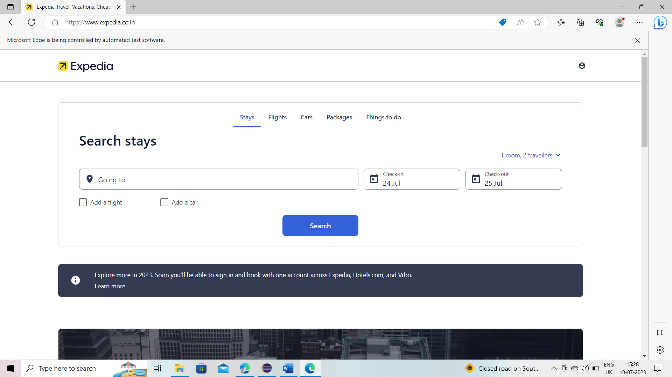

**Using Selenium WebDriver, write a program to handle alerts**

AlertMessage:

**package** demo;

**import** org.openqa.selenium.By;

**import** org.openqa.selenium.edge.EdgeDriver;

**public** **class** AlertMessage {

**public** **static** **void** main(String[] args) **throws** InterruptedException {

// 1)open the browser

EdgeDriver driver = **new** EdgeDriver();

// 2) maximize it

driver.manage().window().maximize();

// 3)navigate to application

driver.get("https://retail.onlinesbi.sbi/retail/login.htm");

// 4) click on continue to login button

driver.findElement(By.*linkText*("CONTINUE TO LOGIN")).click();

// 5) click on login button

driver.findElement(By.*id*("Button2")).click();

Thread.*sleep*(3000);

// 6) close the alert box

driver.switchTo().alert().accept();

}

}

**Output:**

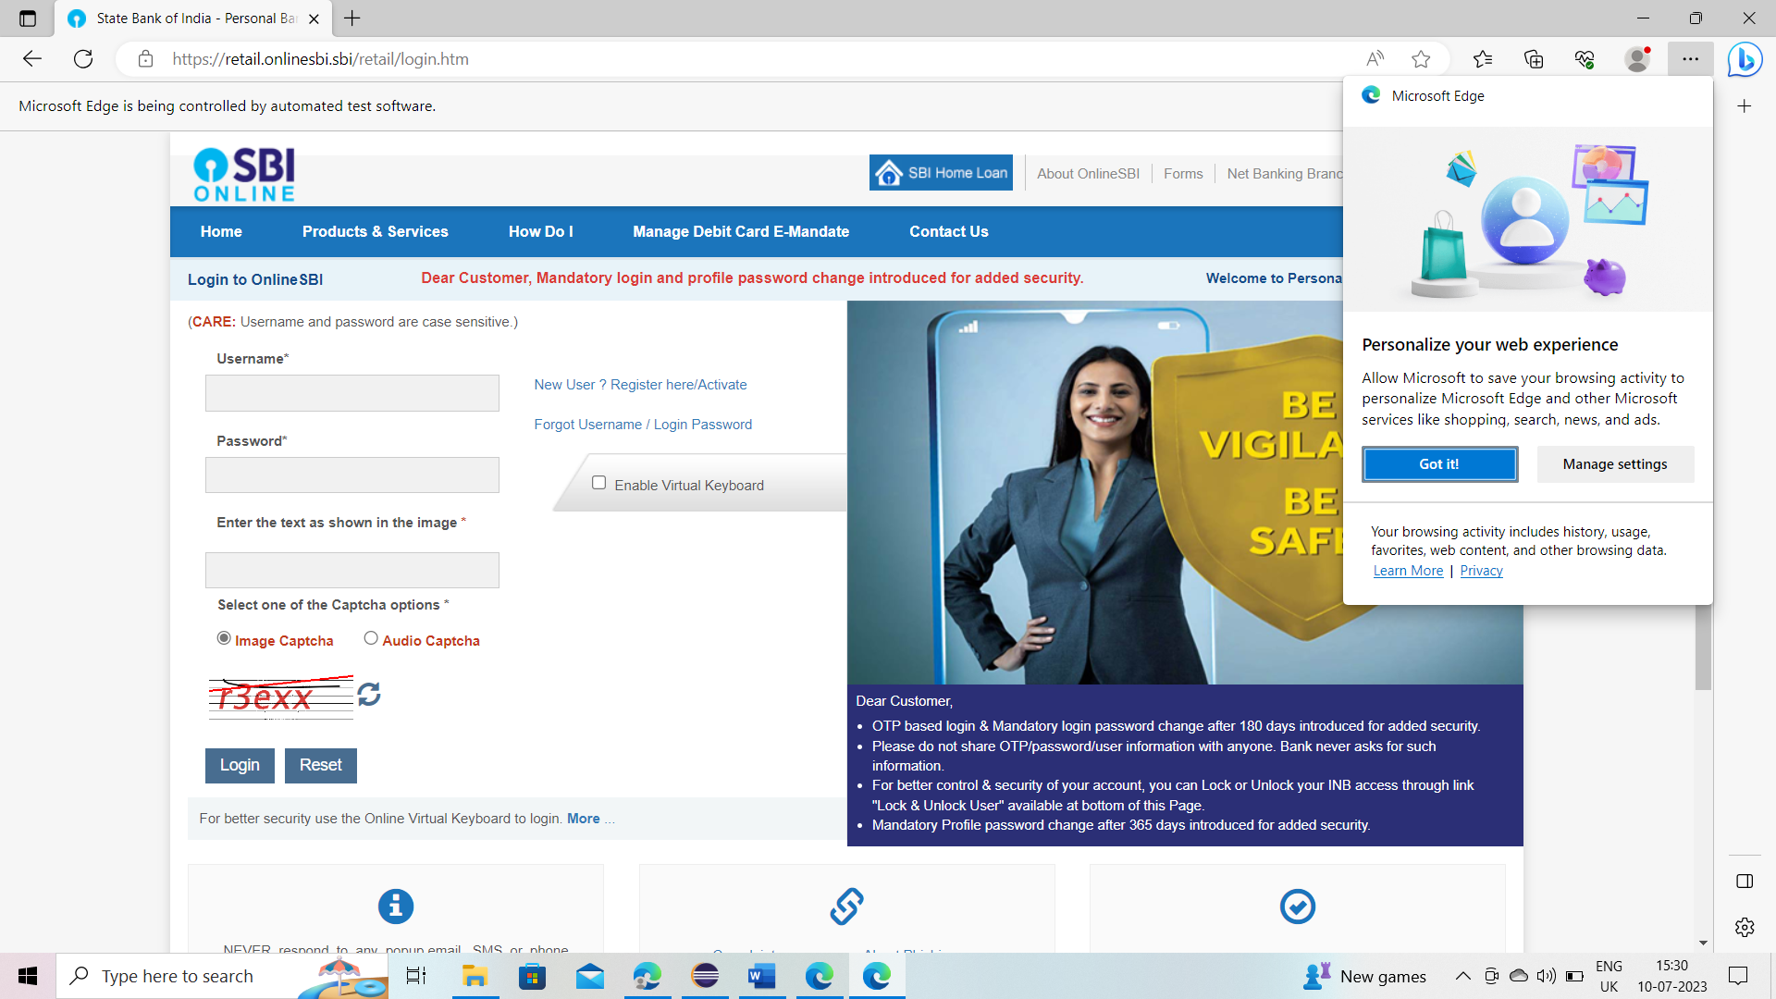

**Switching tabs:**

**package** demo;

**import** java.time.Duration;

**import** java.util.ArrayList;

**import** org.openqa.selenium.By;

**import** org.openqa.selenium.edge.EdgeDriver;

**import** org.openqa.selenium.support.ui.ExpectedConditions;

**import** org.openqa.selenium.support.ui.WebDriverWait;

**public** **class** switchingtabs {

**public** **static** **void** main(String[] args) **throws** InterruptedException{

// 1) Open the browser

EdgeDriver driver = **new** EdgeDriver();

// 2) maximize the window

driver.manage().window().maximize();

// 3) Navigate the application

driver.get("https://www.facebook.com");

// 4) click on instagram

driver.findElement(By.*linkText*("Instagram")).click();

// 5) switch focus on new tab

ArrayList<String> tabs = **new** ArrayList<>(driver.getWindowHandles());

driver.switchTo().window(tabs.get(1));

// wait for the next page to load completely

WebDriverWait wait = **new** WebDriverWait(driver, Duration.*ofSeconds*(60));

wait.until(ExpectedConditions.*visibilityOfElementLocated*(By.*name*("username")));

// 6) write a mail id

driver.findElement(By.*name*("username")).sendKeys("nandhu@gmail.com");

}

}

**Output:**

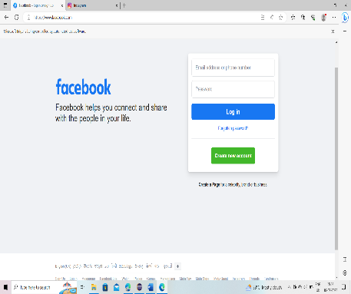

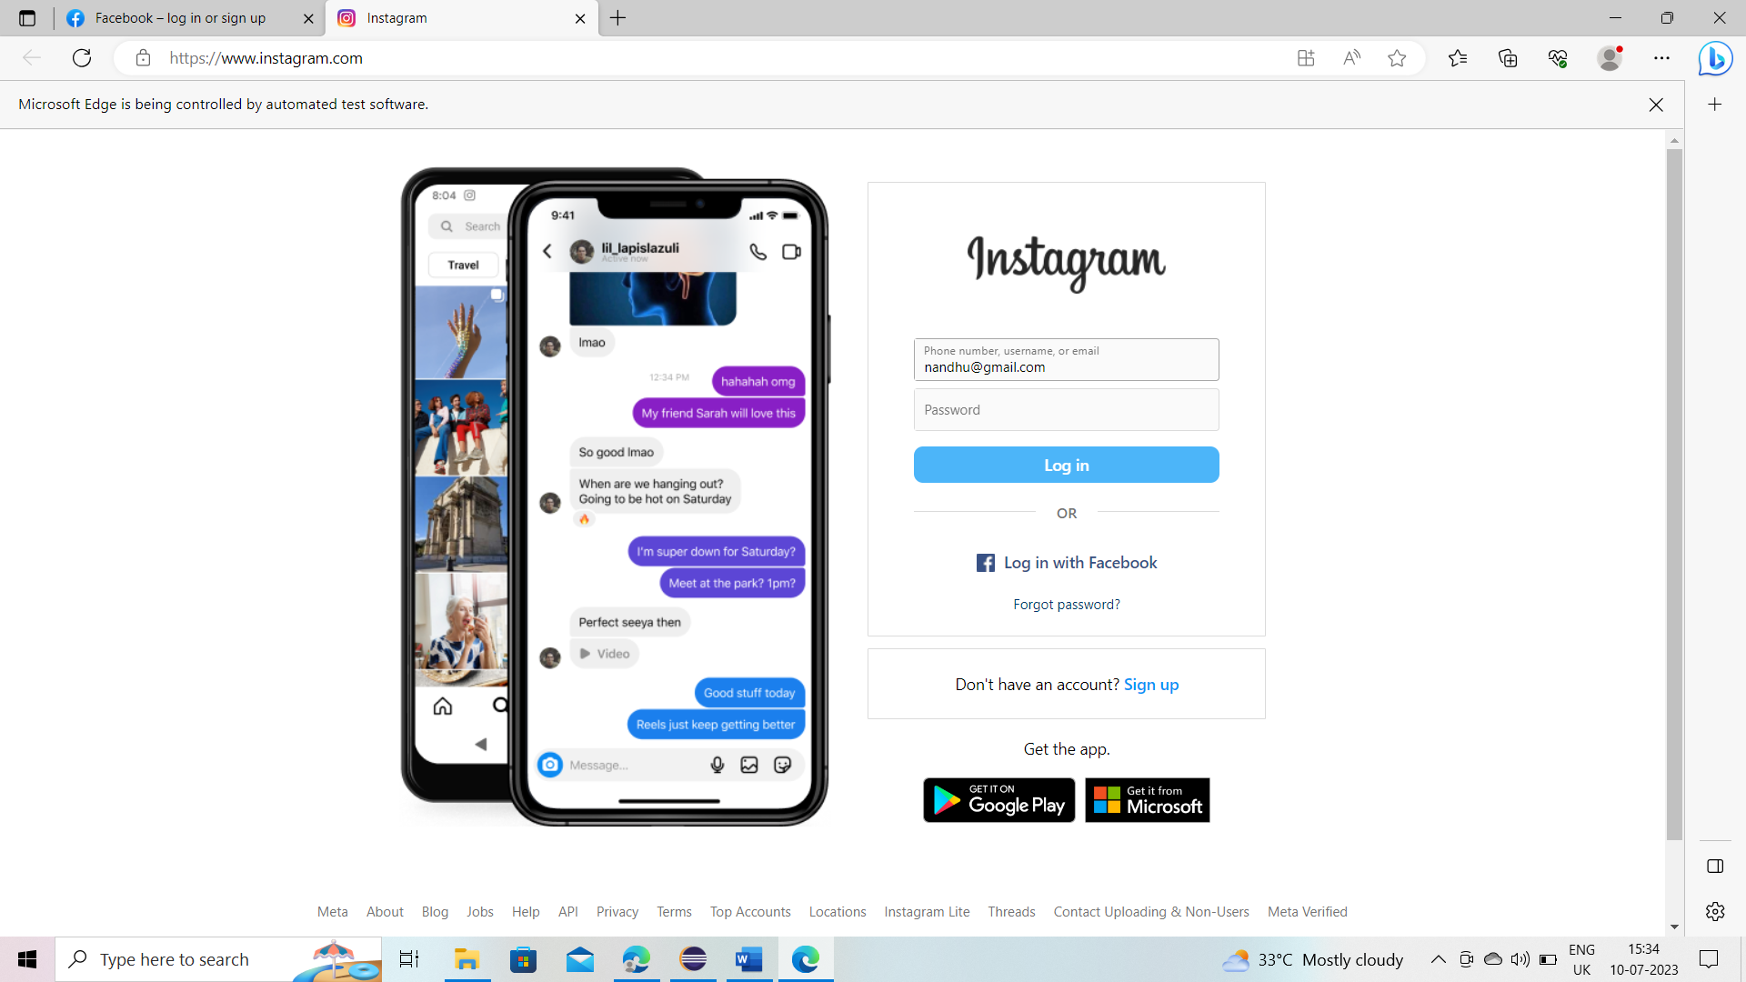

Frame demo:

**p**ackage demo;

**import** org.openqa.selenium.By;

**import** org.openqa.selenium.edge.EdgeDriver;

**public** **class** framedemo {

**public** **static** **void** main(String[] args) {

// 1)open the browser

EdgeDriver driver = **new** EdgeDriver();

// 2) maximize it

driver.manage().window().maximize();

// 3) navigate to the application

driver.get("https://www.selenium.dev/selenium/docs/api/java/index.html?overview-summary.html");

// 4) go inside the frame that contains the deprecated hyperlink

driver.switchTo().frame("classFrame");

// 4) click on deprecated

driver.findElement(By.*linkText*("DEPRECATED")).click();

}

}

Output:

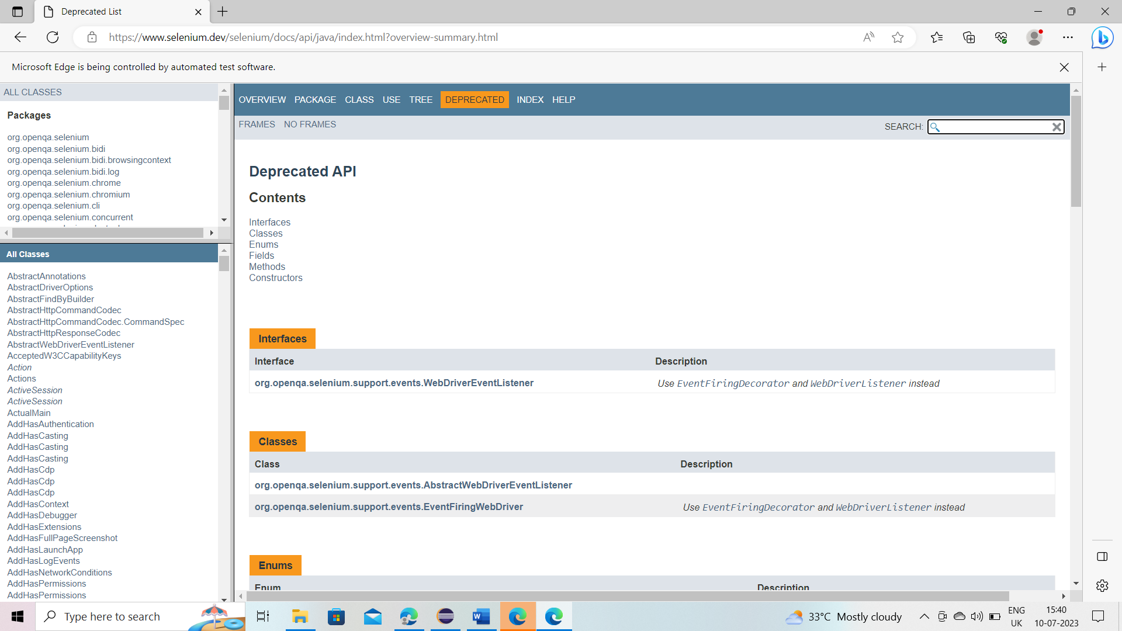

Mousehover:

**package** demo;

**import** java.time.Duration;

**import** org.openqa.selenium.By;

**import** org.openqa.selenium.edge.EdgeDriver;

**import** org.openqa.selenium.WebElement;

**import** org.openqa.selenium.interactions.Actions;

**import** org.openqa.selenium.support.ui.ExpectedConditions;

**import** org.openqa.selenium.support.ui.WebDriverWait;

**public** **class** mousehover {

**public** **static** **void** main(String[] args) {

// 1)open the browser

EdgeDriver driver = **new** EdgeDriver();

// 2) maximize it

driver.manage().window().maximize();

// 3) navigate to the application

driver.get("https://ebay.com");

// 4)Hover the pointer over motors

WebElement motors = driver.findElement(By.*linkText*("Motors"));

Actions actions = **new** Actions(driver);

actions.moveToElement(motors).build().perform();

WebDriverWait wait = **new** WebDriverWait(driver, Duration.*ofSeconds*(60));

wait.until(ExpectedConditions.*visibilityOfElementLocated*(By.*linkText*("Engines and parts")));

// 5) click on engine & parts

driver.findElement(By.*linkText*("Engines and parts")).click();

}

}

Output:

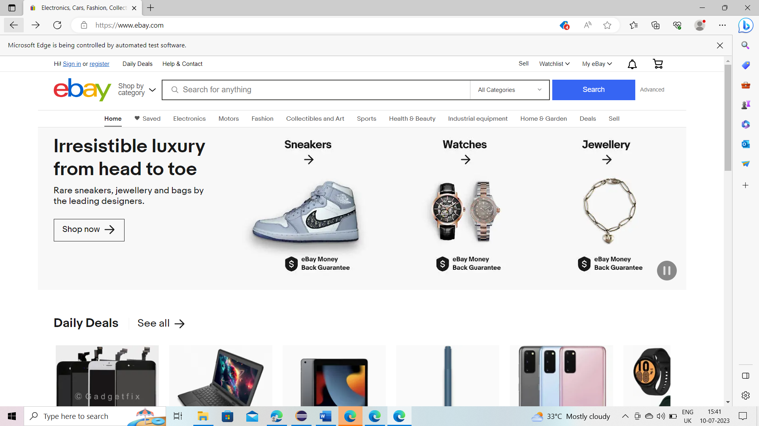

**Demonstrate how screenshots are captured and Demonstrate browser profiles are changed in Selenium**

**Browsing profiles:**

**package** demo;

**import** org.openqa.selenium.edge.EdgeDriver;

**import** org.openqa.selenium.edge.EdgeOptions;

**public** **class** browserprofiling {

**public** **static** **void** main(String[] args) {

EdgeOptions options = **new** EdgeOptions();

options.addArguments("--disable-notifications");

EdgeDriver driver = **new** EdgeDriver();

driver.manage().window().maximize();

driver.get("https://yatra.com");

}

}

**Output:**

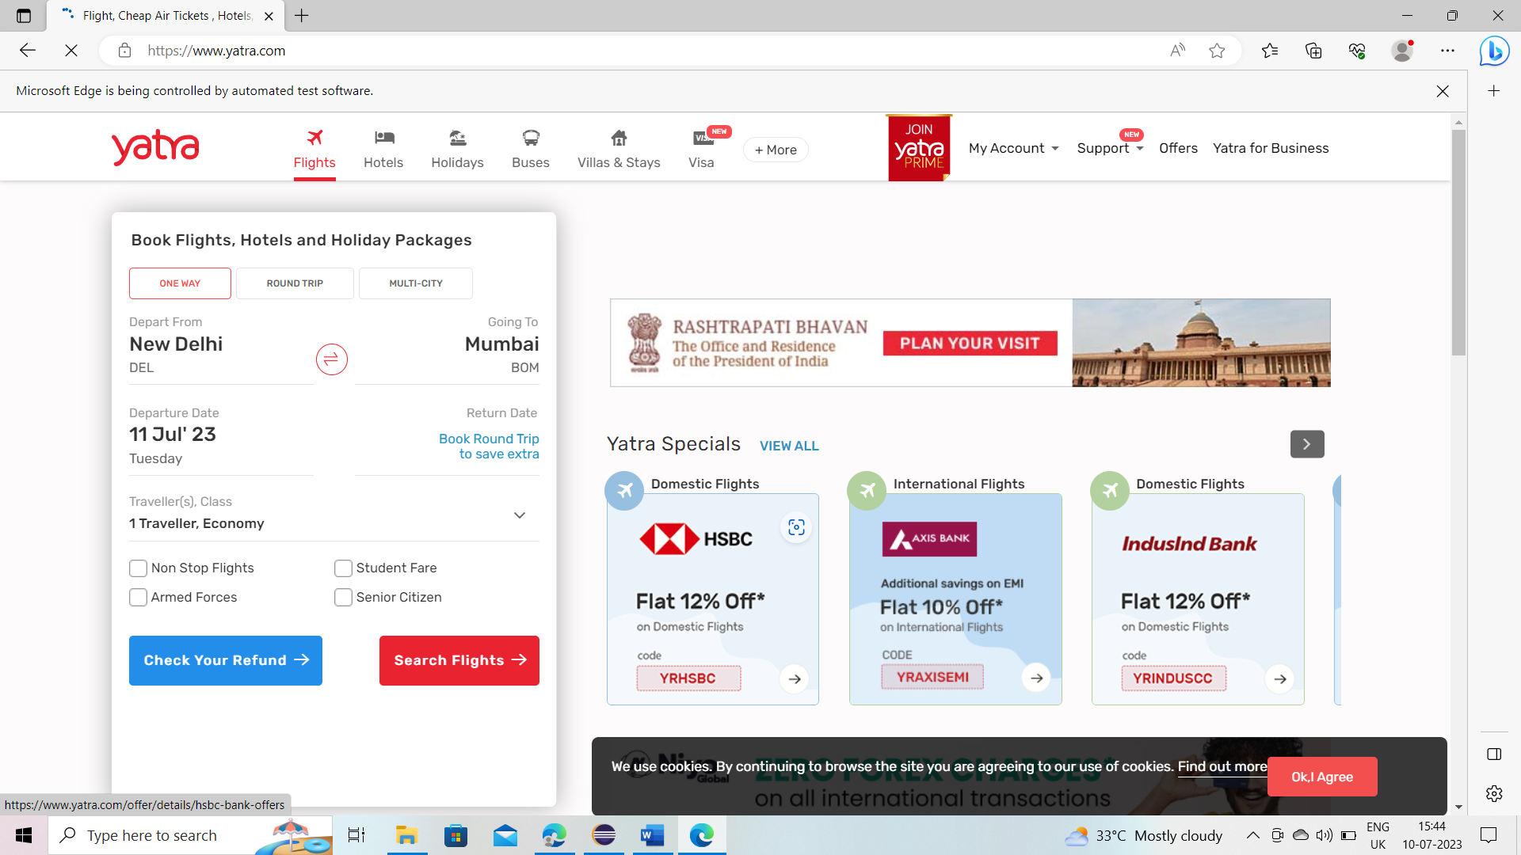

**Demonstrate how file uploads are handled in AutoIT**

**package** demo;

**import** java.io.IOException;

**import** org.openqa.selenium.By;

**import** org.openqa.selenium.edge.EdgeDriver;

**public** **class** uploadfile {

**public** **static** **void** main(String[] args) **throws** IOException, InterruptedException {

// 1) open the browser

EdgeDriver driver = **new** EdgeDriver();

// 2) maximize it

driver.manage().window().maximize();

// 3) navigate to the application

driver.get("https://www.remove.bg/");

// 4) click 'select files to upload' button

driver.findElement(By.*xpath*("//button[contains(@type, 'button')])[3]")).click();

Thread.*sleep*(3000);

// 5) handover the control to autoIt to select the files from the local machine, click on 'open' button.

Runtime.*getRuntime*().exec("resource//upload file.exe");

}

}

**Output:**

